Analyzing the updateability of a join view

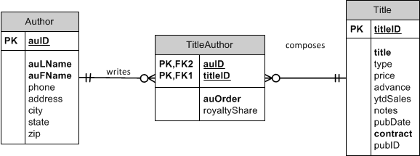

Consider this view:

CREATE OR REPLACE VIEW Oaklanders

AS

SELECT auFName AS First, auLName AS Last, t.titleID, title

FROM Author a JOIN TitleAuthor ta ON a.auID = ta.auID

JOIN Title t ON ta.titleID = t.titleID

WHERE city = 'Oakland'

AND state = 'CA';

|  |  |  |  |  |
| --- | --- | --- | --- | --- |
| Author table | | TitleAuthor | Title Table | |
| First (auFName) | Last (auLName) |  | t.titleID | title |

Is this view updateable?

* Yes

How Do you know?

* First, we need to determine the key-preserved table (without regard for the attributes actually selected in the SELECT clause)
  + The key-preserved table will generally be on the “many” side of a one-to-many relationship. And it often a joining table. In this case, TitleAuthor is on the many side of “writes” and “composes”
* **A DELETE statement against this view will delete rows from the TitleAuthor table.**
* Only the fields from **TitleAuthor can be edited** with an UPDATE. Our SELECT clause does not include any fields from TitleAuthor, so you cannot use the UPDATE statement or the INSERT statement

Try it!

* Delete statement

DELETE FROM Oaklanders

WHERE titleID = 'BU1032';

*ROLLBACK;*

* Insert statement

INSERT INTO Oaklanders

VALUES (‘Tanya’, ‘G’, ‘PC1233’, ‘DB is Fun’);

*FAILS because the select clause doesn’t have any fields from our key-preserved table

Consider this view:

CREATE OR REPLACE VIEW Oaklanders

AS

SELECT auFName AS First, auLName AS Last, ta.titleID, title

FROM Author a JOIN TitleAuthor ta ON a.auID = ta.auID

JOIN Title t ON ta.titleID = t.titleID

WHERE city = 'Oakland'

AND state = 'CA';

|  |  |  |  |
| --- | --- | --- | --- |
| Author | | TitleAuthor | Title table |
| auFName | auLName | Ta.titleID | title |

Is this view updateable?

* Yes

Why and how?

* TitleAuthor is the key-preserved table
* The titleID field comes from the TitleAuthor table.
* Inserts cannot be performed because the view does not include the required fields of ta.titleID and ta.auOrder
* Updates and deletes are allowed (provided the updates do not violate any other constraints).

Try it!

* Update statement

UPDATE Oaklanders

SET titleID = 'BU7832'

WHERE titleID = 'BU1032';

*ROLLBACK;*

* What happened?
* Insert a record so we can update our view

Insert into title (titleID, title, contract) values ('TL1111','DB is the best',1);

* Now update

UPDATE Oaklanders

SET titleID = 'TL1111'

WHERE titleID = 'BU7832';

* Check that our new row is there.

SELECT *

FROM TitleAuthor

WHERE titleID IN ('BU7832', 'TL1111');

*ROLLBACK;*

* Delete statement

DELETE FROM Oaklanders

WHERE titleID = 'BU1032';

*ROLLBACK;*

On the DELETE statement, it’s only deleting 1 of the records (of the possible 2 for that titleID) in TitleAuthor since there is only 1 of those authors from Oakland (IE, appearing in the view).

Consider this view:

CREATE OR REPLACE VIEW Oaklanders

AS

SELECT ta.auID, auFName AS First, auLName AS Last, ta.titleID, title, ta.auOrder

FROM Author a JOIN TitleAuthor ta ON a.auID = ta.auID

JOIN Title t ON ta.titleID = t.titleID

WHERE city = 'Oakland'

AND state = 'CA';

|  |  |  |  |  |  |
| --- | --- | --- | --- | --- | --- |
| Author Table | | TitleAuthor Table | | | Title Table |
| auFName | auLName | auOrder | **auID** | **titleID** | title |

Is this view updateable?

* Yes!

Why and how?

* TitleAuthor is the key-preserved table
* The titleID field comes from the TitleAuthor table
* Inserts can be performed because the view **DOES INCLUDE ALL REQUIRED FIELDS** (of the key-preserved table) (provided the inserts do not violate any other constraints)
* Updates and deletes are allowed (provided the updates do not violate any other constraint).

Try it!

* INSERT

INSERT INTO Oaklanders (auID, titleID, auOrder)

VALUES ('213-46-8915', 'BU1111', 3);

*ROLLBACK;*

* INSERT

UPDATE Oaklanders

SET titleID = 'BU7832'

WHERE titleID = 'TL1111';

*ROLLBACK;*

* Delete statement

DELETE FROM Oaklanders

WHERE titleID = 'BU1032';

*ROLLBACK;*

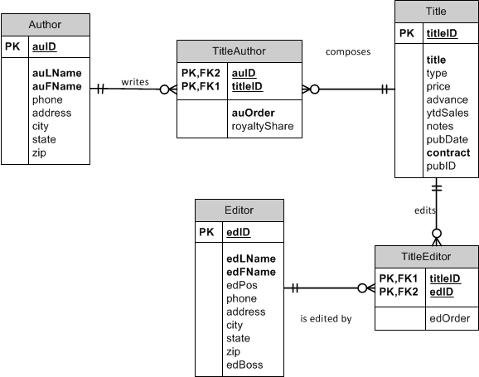

Consider this view:

CREATE OR REPLACE VIEW CompleteBookInfo

AS

SELECT a.auID, auLName AS AuthorLast, auOrder, t.titleID, title, e.edID, edLName AS EditorLast, edOrder

FROM Author a JOIN TitleAuthor ta ON a.auID = ta.auID

JOIN Title t ON ta.titleID = t.titleID

JOIN TitleEditor te ON t.titleID = te.titleID

JOIN Editor e ON te.edID = e.edID;

|  |  |  |  |  |  |  |  |
| --- | --- | --- | --- | --- | --- | --- | --- |
| Author | | TitleAuthor | Title | | Editor | | TitleEditor |
| auID | AuthorLast | auOrder | titleID | Title | edID | EditorLast | edOrder |

Is this view updateable?

No, this view is not updatable.  
  
Why?

* There nis no key-preserved table!
* The key of the view comes from the many sides of our relationships, which in this case is TitleAuthor and TitleEditor:
  + titleID, auID, edID
* Since there is no one table that has that combination as a key, there is no key-preserved table. Therefore, no updates can be made.

You can try some updates:

UPDATE CompleteBookInfo

SET auOrder = 5

WHERE titleID = 'BU1032';

UPDATE CompleteBookInfo

SET AuthorLast = 'Lung'

WHERE auID = '213-46-8915';

UPDATE CompleteBookInfo

SET edOrder = 5

WHERE edID = '321-55-8906'